1.

|  |  |  |  |  |  |
| --- | --- | --- | --- | --- | --- |
| Column Name | student_id | last_name | first_name | credits | graduation_date |
| Key Type PRIMARY KEY FOREIGN KEY | | | | | |
| Nulls/Unique NO/YES NO/NO NO/NO NO/NO YES/NO | | | | | |
| FK Column | | | | | |
| Datatype | NUMBER | VARCHAR2 | VARCHAR2 | NUMBER | DATE |
| Length | |  | |  | |

6 75 75 6

2.

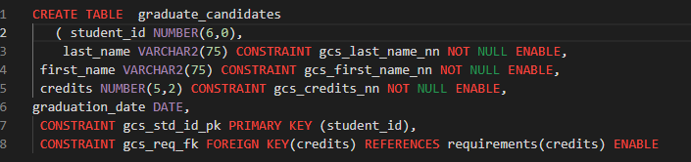

4.



5.

